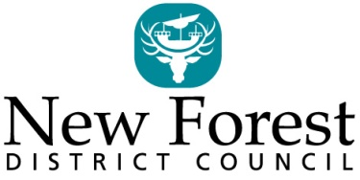

Licensing Act 2003
Notice of an application for new premises licence/club premises certificate

I/We do hereby give notice that I/we have applied to the Licensing Authority at New Forest District Council for a new premises/club premises certificate as detailed below:-
Name of applicant(s)
Address of premises
Proposed Licensable Activities together with the relevant times.
Any person wishing to make representations in respect of this application may do so by writing to: Licensing Services, New Forest District Council, Appletree Court, Beaulieu Road, Lyndhurst, SO43 7PA or via email at licensing@nfdc.gov.uk

no later than: ………………………………………..
(date-28 days after posting of this notice)
Representations received after this date cannot be considered.
A record of this application is available to view during office hours at the above offices or via www.newforest.gov.uk. It is an offence knowingly or recklessly to make a false statement in connection with this application, punishable on summary conviction by an unlimited fine.
Dated:

