Food Hygiene Rating Scheme:  ‘Right to reply’ |  | 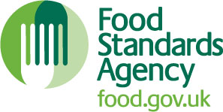  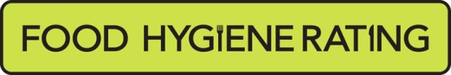

Notes for businesses:

- As the food business operator of the establishment you have a ‘right to reply’ in respect of the food hygiene rating given following your inspection.
- The purpose is to enable you to give an explanation of subsequent actions that have been taken to make the required improvements as detailed in the inspection letter, or to explain mitigation for the circumstances at the time of the inspection. It is not for making complaints or for criticising the scheme or food safety officer.
- If you wish to use this ‘right to reply’, please use the form below and return it to the food safety officer that undertook your inspection - contact details are provided with the written notification of your food hygiene rating.
- Your comments will be reviewed by the food safety officer and may be edited in order to remove offensive or defamatory remarks before being published online and displayed together with your food hygiene rating at food.gov.uk/ratings.
- There will be a statement at food.gov.uk/ratings that will highlight that the accuracy of your comments has not been verified by local authority officers.

Business details
Food business operator/proprietor

Business name

Business addresses

Inspection details
Date of inspection |  |  |  |  | Food hygiene rating given

Comments
I agree with the inspection results but have since carried out the following improvements (tick all that apply):
The establishment has been thoroughly cleaned and procedures are in place to ensure that cleanliness is maintained.
The establishment has been or will shortly be fully renovated.
A new management system has been implemented.
There is now a new manager and/or new staff.
The staff have been trained/re-trained/given instruction/are under revised supervisory arrangements.
Other – please specify below.
The conditions found at the time of the inspection were not typical of the normal conditions maintained at the establishment and arose because (Please explain below and use only the space provided. You can also state any other improvements made):
Signature
Name in capitals

Position |  | Date
Please now return this form to: NEW FOREST DISTRICT COUNCIL, ENVIRONMENTAL HEALTH (COMMERCIAL), APPLETREE COURT, BEAULIEU ROAD, LYNDHURST, HAMPSHIRE, SO43 7PA
Alternatively email to hygiene.rating@nfdc.gov.uk

