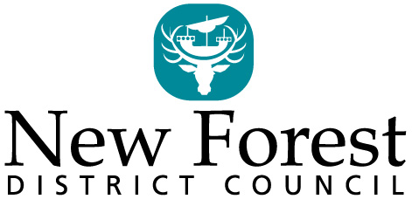
PUBLIC NOTICE
Application for a Pavement Licence
Business and Planning Act 2020
Levelling Up and Regeneration Act 2023
I/We (name of applicant(s))

do hereby give notice that on  (date of application) | / /
I/we have applied to New Forest District Council for a Pavement Licence at:
(name of premises and address and description of area to be covered by the pavement Licence, including dimensions)

The application is for:
(brief description of use of area (e.g. outdoor seating to the front of the premises for serving of food and drink)

Full details of the application can be viewed at during office hours, at New Forest District Council, Licensing Services, Appletree Court, Beaulieu Road, Lyndhurst, SO43 7PA.
Any person who wishes to make any representations regarding this application should submit their comments in writing or by email to licensing@nfdc.gov.uk or to the above address, no later than:
/ / Date
(14 days starting the day after the application was submitted)

Date notice placed on premises / / (same date as the date of application)

